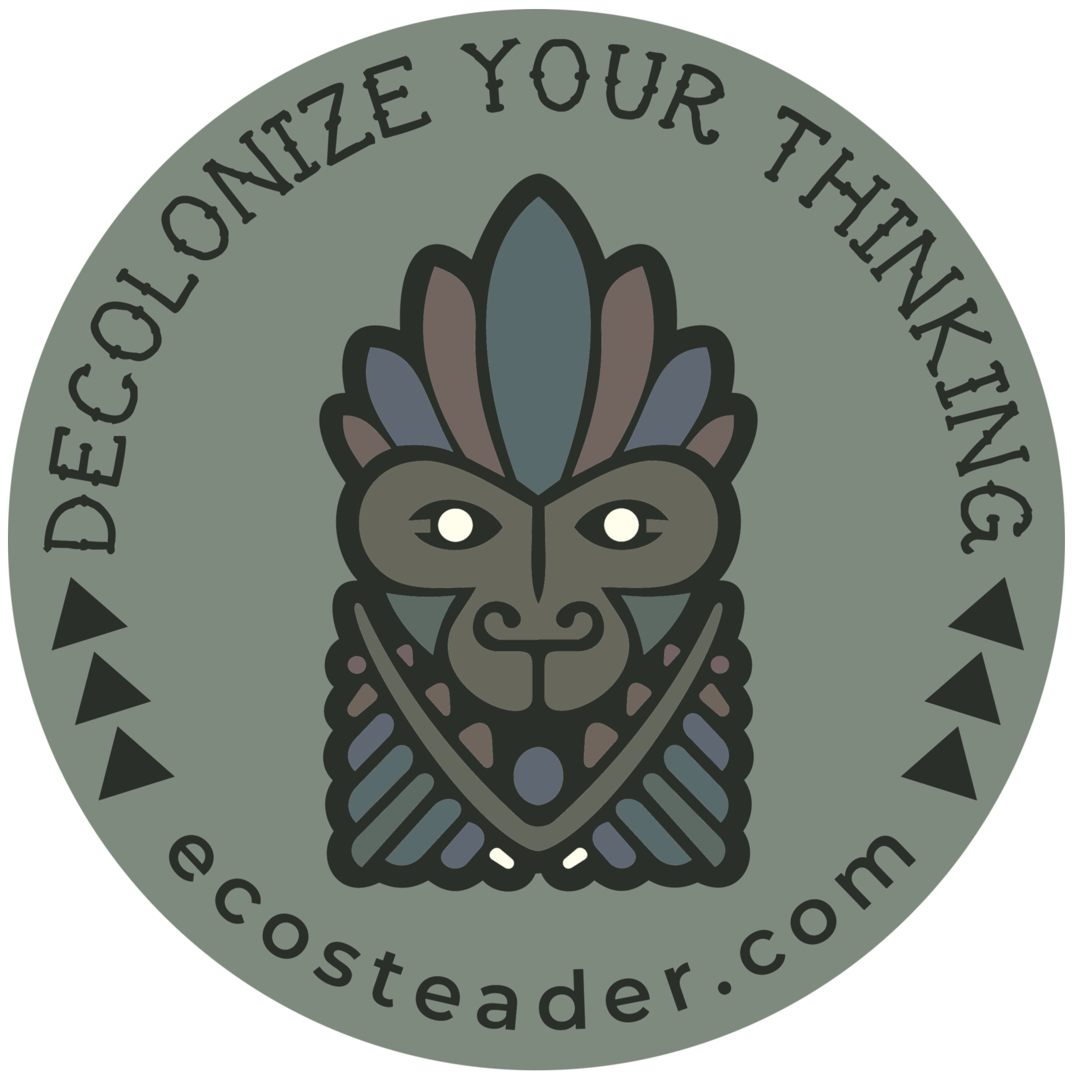Decolonization

for Survivors

Ecosteader & Company

ecosteader.com

b company for public benefit

Winter Solstice 2019

This compilation contains many corrections to history that descendants of white settler colonialism may not be aware of.

Listen at least twice as hard before you think to speak; not everything translates to English. In fact, almost nothing does.

“Decolonize the concepts. Indigenous communities have the power, strength, and intelligence to develop culturally-specific strategies of liberation, health, and well-being. Indigenous people have the right to accept new ways of thinking, reconstruct them, or to deny them.

Translation is not only encouraged but necessary.”[1]

For more info on the artwork sources, adaptations, and the use of symbols among various First Nations, see: <https://ecosteader.com/tags/indigenous>

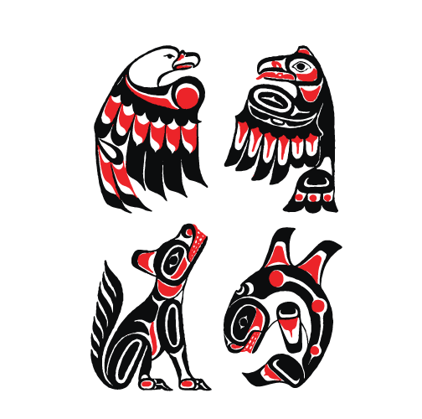  
Illustration 1: Figure ㉠: Kitasoo / Xai’xais “The First Nations community of Klemtu in the heart of the Great Bear Rainforest.”

“American colonial ideas of self-government came as much from the colonists’ observations of tribal governments as from their Protestant or Greco-Roman heritage. Neither Greece nor Rome had the kind of pluralistic democracy as that concept had been understood in the United States since Andrew Jackson, but the tribes, particularly the gynarchical tribal confederacies, did. It is true that the *oligarchic* form of government that colonial Americans established was originally based on Greco-Roman systems in a number of ways, such as its restriction of citizenship to propertied white males over twenty-one years of age, but it was never a form that Americans as a whole have been entirely comfortable with. Politics and government in the United States during the Federalist period also reflected the English common law system as it had evolved under patriarchal feudalism and monarchy – hence the United States’ retention of slavery and restriction of citizenship to propertied white males.”

~ Paula Gunn Allen “Pushing Up the Sky”. The Sacred Hoop 1986

“[Settler colonialism](https://www.tandfonline.com/doi/full/10.1080/14623520601056240) is said to be a structure, not an historic event, whose endgame is always the elimination of the Natives in order to acquire their land, which it does in countless seen and unseen ways. These techniques are woven throughout the US’s national discourse at all levels of society. … in this program, genocide and land dispossession are continually both justified and denied.

Like white fragility, settler fragility is the inability to talk about unearned privilege—in this case, the privilege of living on lands that were taken in the name of democracy through profound violence and injustice. Like white privilege, white supremacy is also at the root of settler fragility. The difference is that foreign invasion, dispossession of Indigenous lands, and genocide were based on (white) European religious and cultural supremacy as encoded in the [doctrine of discovery](https://upstanderproject.org/firstlight/doctrine/), not racial supremacy.

An orientation to land and place based on the four R’s must also take into consideration society’s relationship to Indigenous peoples and its domination-based paradigm. Settler society can then finally be accountable for its genocidal and whitewashed historical narratives.

In these ways, settler society can construct a land- and place-based ethic that affirms life in all its forms and help ensure the futurity and diversity of all human and nonhuman communities. ”

~ [Dina Gilio-Whitaker](https://www.beaconbroadside.com/broadside/dina-gilio-whitaker/) “[Mainstream Settler Society Needs a Land- and Place-Based Ethic](https://www.beaconbroadside.com/broadside/2019/05/mainstream-settler-society-needs-a-land-and-place-based-ethic.html)”

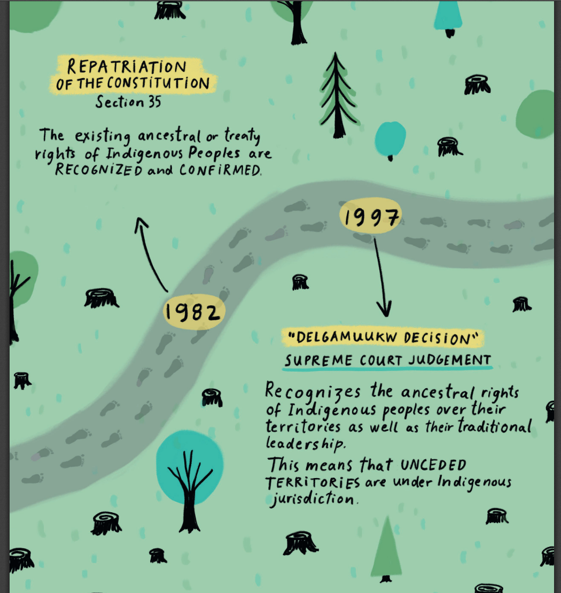  
Illustration 2: Find a copy: https://emsenn.net/why-blockade-the-rails.pdf

**Latter-day Saints AKA “Mormons” are murderers:**

“When the Mormons first reached Utah in 1847, there were an estimated 20,000 Native Americans within the territory. By 1900 the number had plummeted to 2,623. In other words, eighty-six percent of the Indians in Utah vanished in half a century.”

*Decolonization is not a metaphor.* Eve Tuck & K. Wayne Lang 2012

¨Letter to the Crown

https://iaf-fai.org/2020/11/13/letter-to-the-crown/

Honor Indigenous Peoples

NOT COLUMBUS.

NOT PIONEERS.

NOT PRESIDENTS.

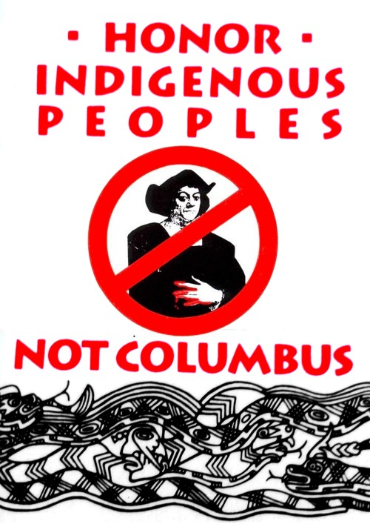

ABOUT **#MMIW**

MMIW = Missing &

Murdered

Indigenous

Women

“The physical and cultural genocide of American Indian tribes is and was mostly about patriarchal fear of women. The [insert western Christian denominations] missionaries ... could not tolerate peoples who allowed women to occupy prominent positions and decision-making capacity at every level of society.” **-Paula Gunn Allen**

Both Canada and the US governments have a sordid history of harassing and killing First Nations peoples, raping and plundering the natural resources on their lands, and leaving a wake of pollution and destruction that money can’t clean up.

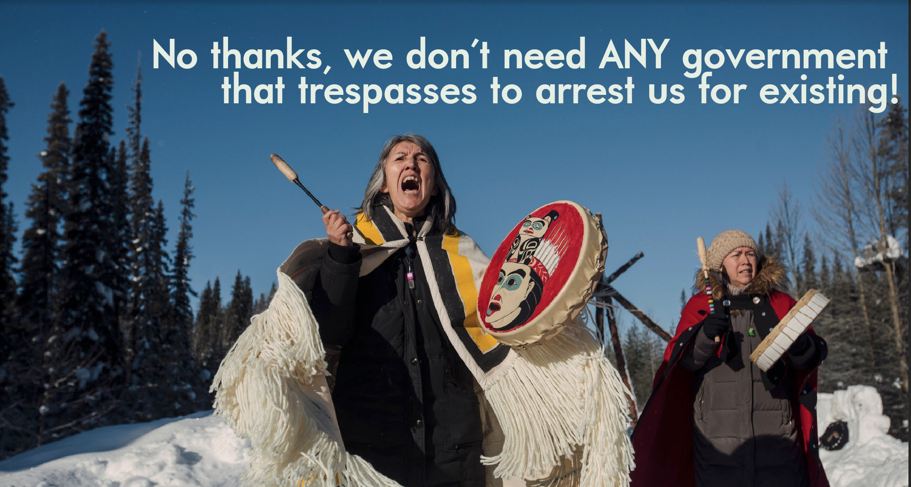Wet’suwet’en /unistoten.camp/

Apache Solidarity /apache-stronghold/

**Winter 2019**

Australia’s burning

Colonial economics are stupid and bad

(BTW YOU ARE STILL FAILING ON ALL CONTINENTS)

White supremacists have no future

Universe’s extreme last call “backup emergency plan” to save baby Yodas

Koalas

Unique marsupial species

with as many rights as

Native Eucalyptus,

Smart teams of birds,

etc.

And its governor goes and tries to hide in Hawai’i?

The US has an [impeached](https://newsmaven.io/indiancountrytoday/news/the-colonizer-s-president-was-impeached-SWStlOlhOUGymRo09L17eg) coward trying to run the show.

Great Britain’s doomed by division.

Canada thinks four-wheelers can replace four-leggeds.

**Spring 2020**

Flooding starting early in Mississippi and Tennessee.

Tornadoes smash through Nashville.

The diseased US President leaks virus and plague from every orifice; he still does not “get it” that money and economics cannot solve problems created by money.

MarkCharles2020.com

“Throughout our history the United States of America has used the separation of families as a means of controlling people of color. Whether during Indian removal, the slave trade, Western Expansion, Internment Camps, Indian boarding schools or in immigration detention centers today - the U.S. government has been stealing babies from their mother’s breasts for nearly 250 years. It is who we are.

It's what our government does.  
  
But it's not who we have to be.  
  
The first step towards change is acknowledging we have a problem. So while this may be who we are, it is not who we have to continue to be. But that is a decision we have to make together, both intentionally and collectively. Our systemic injustice, racism, and implicit bias of white supremacy are not partisan problems. It's a collective problem.”

<https://wirelesshogan.blogspot.com/2018/06/separating-families-its-what-us-has.html>

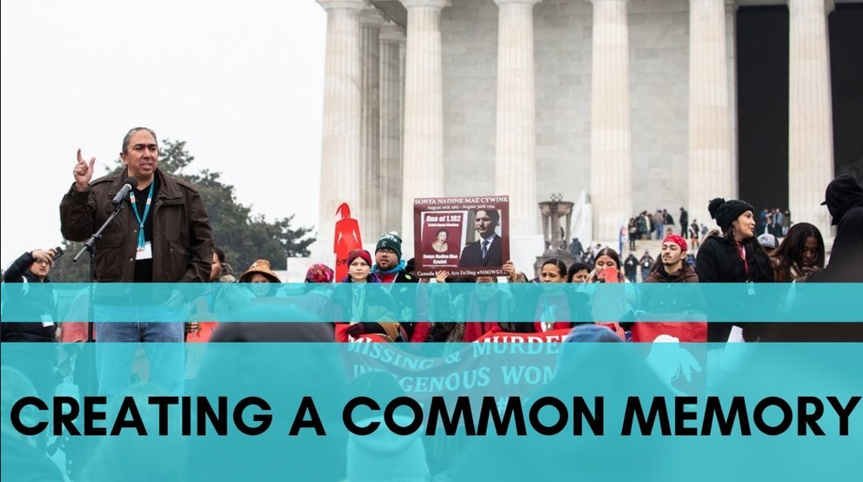

Learn

about Land Acknowledgements

→

READ: “You cannot discover lands already inhabited” Unsettling Truths. *The Ongoing Dehumanizing Legacy of the Doctrine of Discovery.* Mark Charles and Soong-Chan Rah. 2019,

VISIT: [https://native-land.ca](https://native-land.ca/) and figure out whose land you’re on.

Resources include detail about languages, people, trading areas, many of which overlap with ….(get this):

**No walls or official borders.**

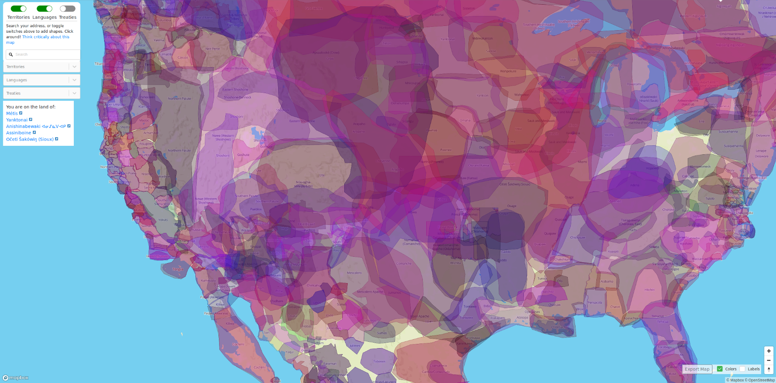*Still here, yup.*

Indigenous peoples' rights:

Use a trailing apostrophe. Ownership belongs to the different peoples.

There are many peoples, and they each have different languages. YO, BE SPECIFIC.

**SAMPLE: Land acknowledgement for a college or educational space**

**“**The [authors] ask readers to acknowledge the <pre-Columbus settlements of the _____ peoples . See also: https://maps.fpcc.ca/> communities, their [leadership/elders], as well as future generations. They acknowledge that the University and the research area were founded upon the exclusion and erasure of many Indigenous peoples, including those on whose land the institution is located and research computed. They acknowledge that the research study was enabled by the past and contemporary land stewardship of local Indigenous peoples. **” Thanks to @lj_writes@fandom.ink for the notes, edits, and discussion on general practices for a land acknowledgement template.**

**Are you ready to tear down the broken systems in favor of one that works?**

**If you ever “forget” why you are not in charge, here’s the syllabus:**

**-----------------------------------------------------------------------------------------------**

**eom**

**-------------------------------------------------------------------------------------------**

STOP NOTICE

ecosystems require

ALL LOCAL FIXES

before any global-oriented move

#ProTip: Subsurface minerals are NOT a right.

Cannot be bought and sold.

If your city doesn’t have a recycling and compost setup from 30+ years ago,

go dig through your landfills instead.

<https://www.youtube.com/watch?v=eAlRwi9mnwA>

Indigenous sovereignty.

Acknowledge it:

Inherent to the particle.

Sovereignty cannot be “granted” by a governmental entity; it can only be **acknowledged** and respected as existing, INDEPENDENT from colonial systems.

That’s right:

Intricate Details

Are usually not possible

in the vicinity of destruction.

Sinkholes happen.

Endnotes // **include** this [**astoundingly obvious advice**](https://ecosteader.com/@indie/103351999727744746):

DO NOT BASE ANYTHING ON A FAILED SYSTEM.

FAILED SYSTEMS INCLUDE OLIGARCHIES LIKE RUSSIA; EXCLUDE PATRIARCHAL OLIGARCHIES AND THE SOCIETIES THAT ENABLE THEM.

FAILED SYSTEMS INCLUDE MONARCHIES; EXCLUDE EUROPEAN MONARCHIES.

* ~ * ~ *

EXCLUDE ALL REALTORS, BROKERS, HOTELIERS, LANDLORDS, PROPERTY MANAGEMENT COMPANIES, LLCS, AND OTHER TRAVESTIES RESULTANT FROM COLONIAL IDEAS ABOUT “HOW TO MAKE MONEY EXPLOITING LAND”. YOU CANNOT DO THIS TOO SOON.

IF YOU WORK FOR THEM, EVEN AS A “SECRETARY”, YOU’RE JUST A COMPLICIT ENABLER.

GET HELP.

THERE ARE NO EXCUSES.

#qmech endnotes:

find: marketing.yml for FAQ

YT: ¨Channel Ecostead¨

Yes, you can support native sovereignty if you want.

This document was created

for the Creative Commons

copyleft 2020

Don’t say you weren’t warned.

Share these ideas.

Be willing to overthrow kyriarchy and corruption.

The lives saved may be your own.

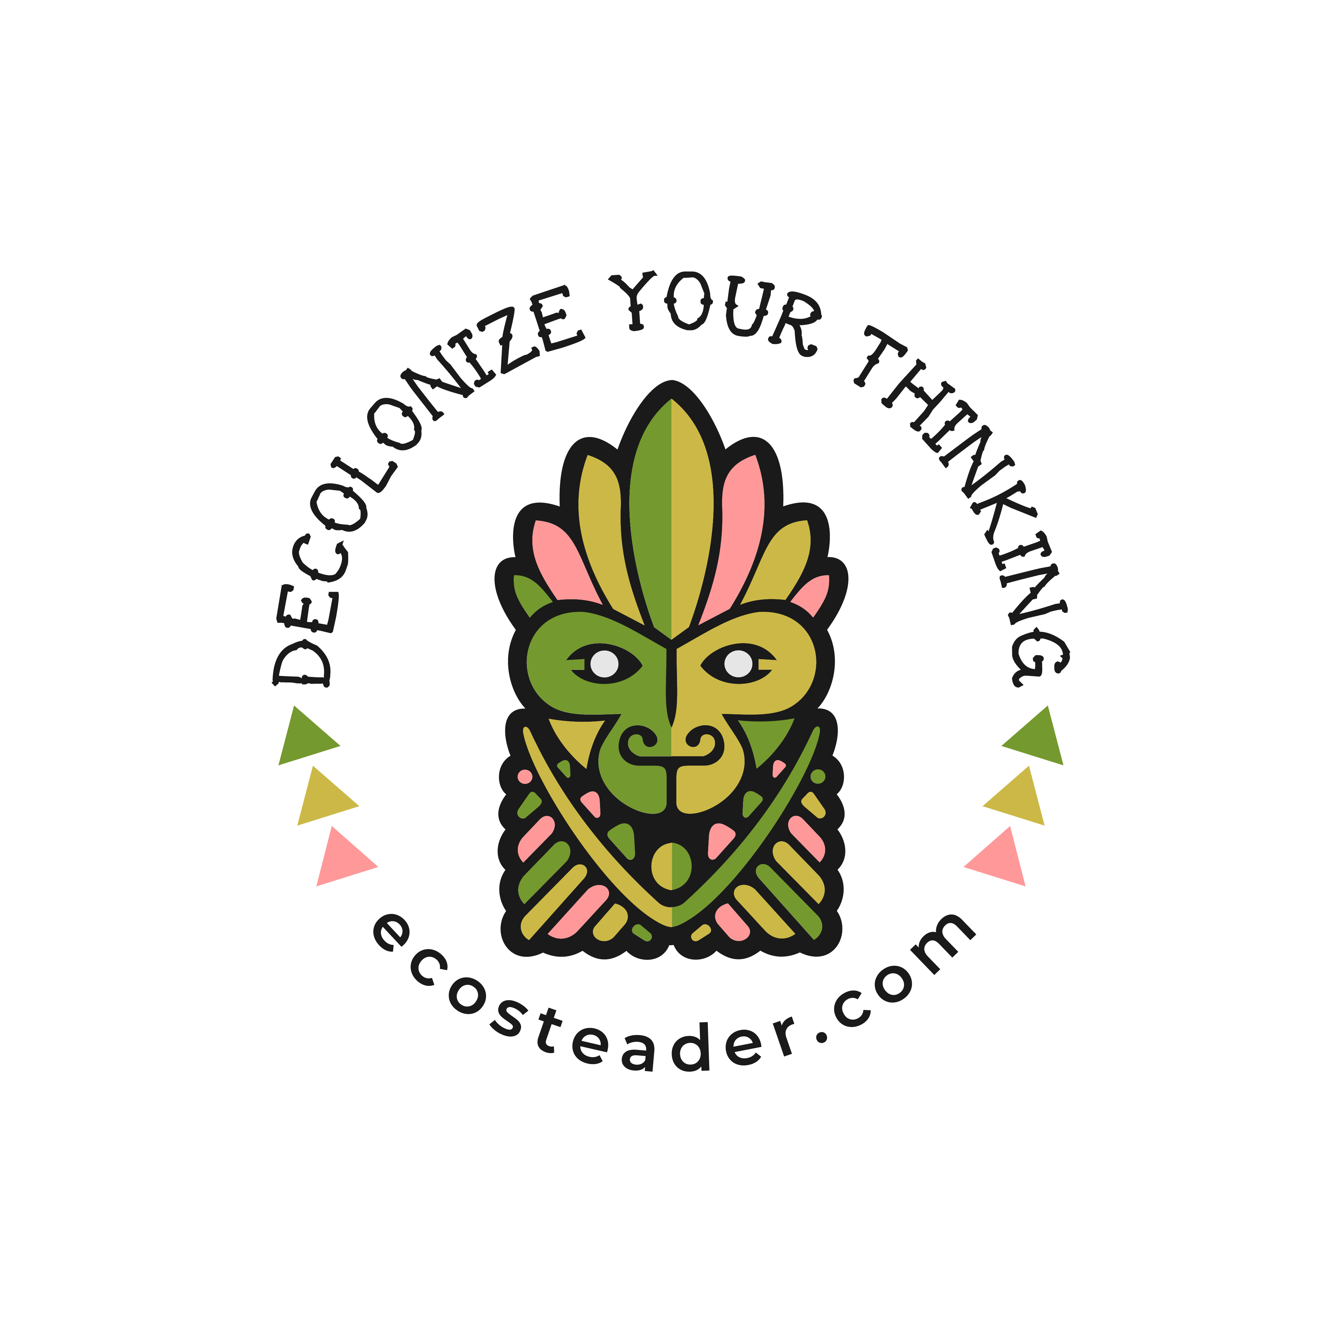

Send fanmail

or requests for decals (SASE + check (any amount))

to

P.O. Box 0013

Forest Grove, OR

TURTLE ISLAND

97116

1. <https://democracycollaborative.org/sites/clone.community-wealth.org/files/downloads/CommunityWealthBuildingALakotaTranslation-final-web.pdf> & <https://ecosteader.com/web/timelines/tag/communitywealth>